

HEART DISEASE DIAGNOSTIC

-

ANALYSIS

DETAILED PROJECT REPORT

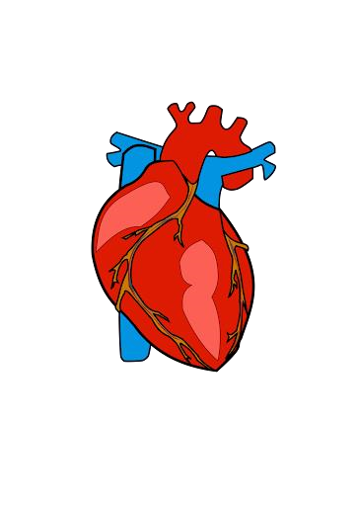

Pavan Kumar Didde



PROJECT DETAIL

**Project Title**

Heart Disease Diagnostic

–

Analysis

**Technology**

Business Intelligence

**Domain**

Healthcare

**Project Difficulty level**

Advanced

**Programming Language Used**

Python

**Tools Used**

Jupyter Notebook, MS

-

Excel, MS

-

Power BI



OBJECTIVE

◆

The goal of this project is to analyse the heart disease

occurrence, based on a combination of features that

describes the heart disease.



PROBLEM STATEMENT

◆

Health is real wealth in the pandemic time we all realized the

brute effects of covid

-

19

on all irrespective of any status. You

are required to analyse this health and medical data for

better future preparation.

◆

A dataset is formed by taking into consideration some of the

information of 303 individuals.



ARCHITECTURE



Raw Data

Collection

Missing Value

Imputations

Data Cleaning

Exploratory

Data Analysis

EDA

)

(

Modelling

Deployment

Reporting

Handling

Outliers

Importing Libraries in

Jupyter Notebook

Load Dataset

Power BI

Desktop

Insights

**Data Pre**

**-**

**Processing**

**Real World**

✓

**Low Level Design Document**

✓

**High Level Design Document**

✓

**Architecture Document**

✓

**Wireframe Document**

✓

**Detailed Project Report**



DATASET INFORMATION

**age:**

The person's age in years

**sex:**

The person's sex (1 = male, 0 = female)

**cp:**

The chest pain experienced (Value 1: typical angina, Value 2: atypical angina,

Value 3: non

-

anginal pain, Value 4: asymptomatic)

**trestbps:**

The person's resting blood pressure (mm Hg on admission to the hospital)

**chol:**

The person's cholesterol measurement in mg/dl

**fbs:**

The person's fasting blood sugar (> 120 mg/dl, 1 = true; 0 = false)

**restecg:**

Resting electrocardiographic measurement (0 = normal, 1 = having ST

-

T

wave abnormality, 2 = showing probable or definite left ventricular

hypertrophy by Estes' criteria)

**thalach:**

The person's maximum heart rate achieved

**exang:**

Exercise induced angina (1 = yes; 0 =

no)

**oldpeak:**

ST depression induced by exercise

relative to rest

**slope:**

the slope of the peak exercise ST

segment (Value 1: upsloping, Value 2: flat,

Value 3: down sloping)

**ca:**

The number of major vessels (0

-

3)

**thal:**

A blood disorder called thalassemia (3 =

normal; 6 = fixed defect; 7 =

reversable defect)

**num:**

Heart disease (0 = no, 1 = yes)

**Age:** Age is the most important risk factor in developing cardiovascular or heart diseases, with approximately a tripling of risk with each decade of life. Coronary fatty streaks can begin to form in adolescence. It is estimated that 82 percent of people who die of coronary heart disease are 65 and older. Simultaneously, the risk of stroke doubles every decade after age 55.

**Sex:** Men are at greater risk of heart disease than pre-menopausal women. Once past menopause, it has been argued that a woman's risk is similar to a man’s although more recent data from the WHO and UN disputes this. If a female has diabetes, she is more likely to develop heart disease than a male with diabetes.

**Resting Blood Pressure:** Over time, high blood pressure can damage arteries that feed your heart. High blood pressure that occurs with other conditions, such as obesity, high cholesterol or diabetes, increases your risk even more.

**Fasting Blood Sugar:** Not producing enough of a hormone secreted by your pancreas (insulin) or not responding to insulin properly causes your body's blood sugar levels to rise, increasing your risk of heart attack.

**Cholesterol:** A high level of low-density lipoprotein (LDL) cholesterol (the "bad" cholesterol) is most likely to narrow arteries. A high level of triglycerides, a type of blood fat related to your diet, also ups your risk of heart attack. However, a high level of high-density lipoprotein (HDL) cholesterol (the "good" cholesterol) lowers your risk of heart attack.

Why These

Parameters

are

Important?

**Resting ECG:** For people at low risk of cardiovascular disease, the USPSTF concludes with moderate certainty that the potential harms of screening with resting or exercise ECG equal or exceed the potential benefits. For people at intermediate to high risk, current evidence is insufficient to assess the balance of benefits and harms of screening.

**Max heart rate achieved:** The increase in the cardiovascular risk, associated with the acceleration of heart rate, was comparable to the increase in risk observed with high blood pressure. It has been shown that an increase in heart rate by 10 beats per minute was associated with an increase in the risk of cardiac death by at least 20%, and this increase in the risk is similar to the one observed with an increase in systolic blood pressure by 10 mm Hg.

**ST Depression:** In unstable coronary artery disease, ST-segment depression is associated with a 100% increase in the occurrence of three-vessel/left main disease and to an increased risk of subsequent cardiac events. In these patients an early invasive strategy substantially decreases death/myocardial infarction.



INSIGHTS

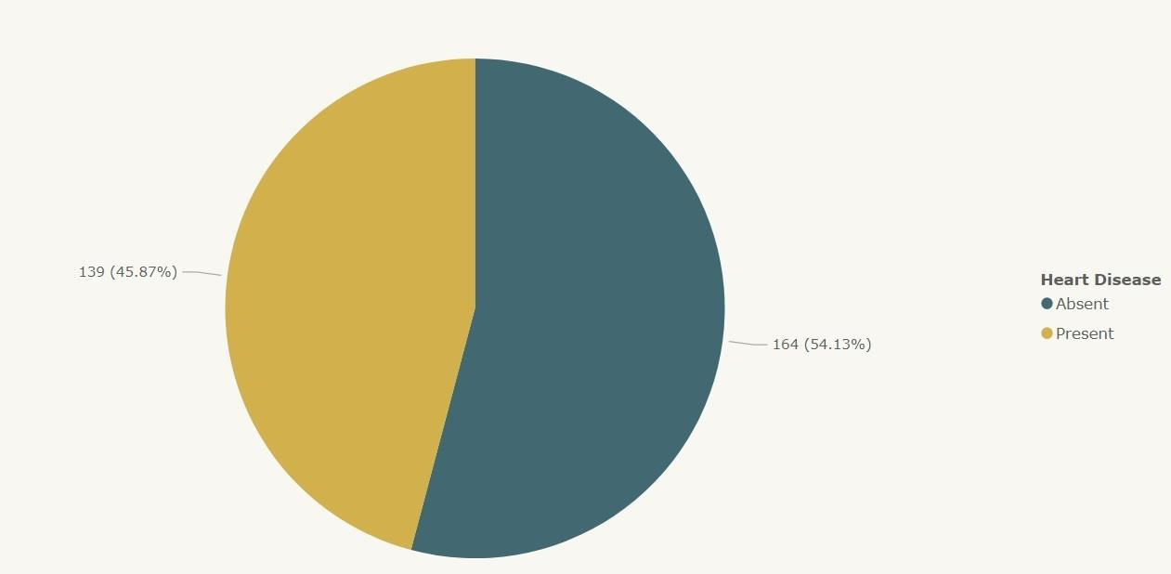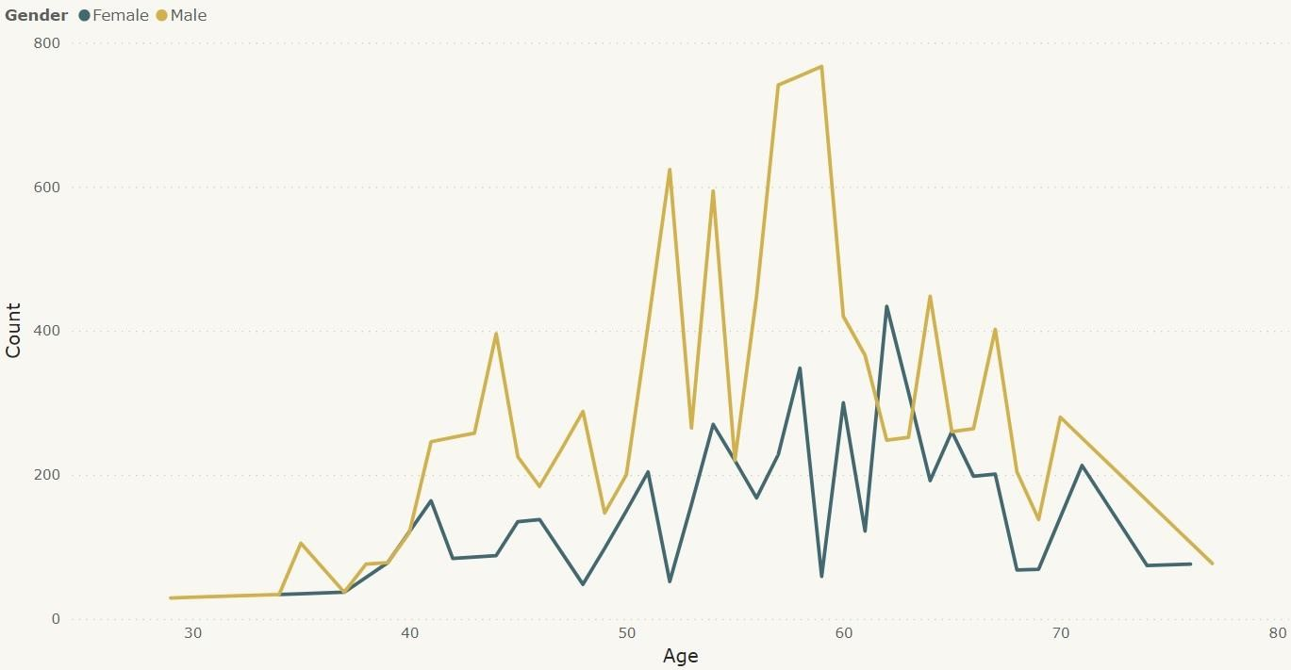

➢

45.87

% People suffering from heart disease.

➢

More men are from age category >50 and

females are from category >55

**What Kind of Population do we have?**

**Who Suffers from Heart Disease?**

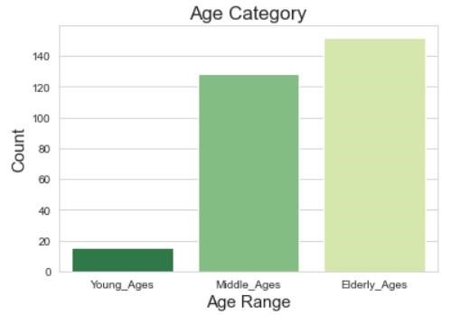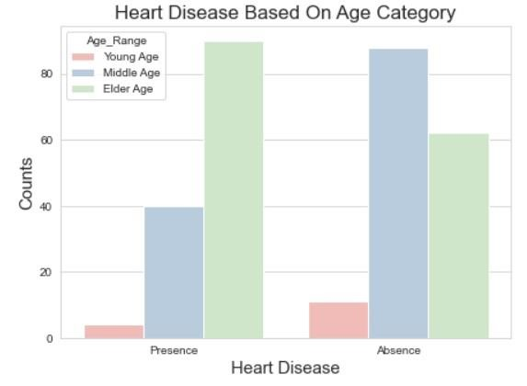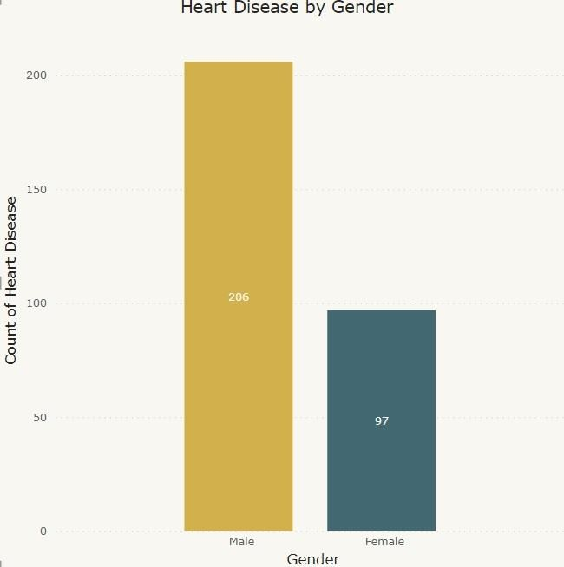

* Elderly Aged People (>55) are more in our population
* Males are more prone to ➢ Elderly Aged People (>55) are heart disease. more prone to heart disease.

# Chest Pain Experienced By Patients

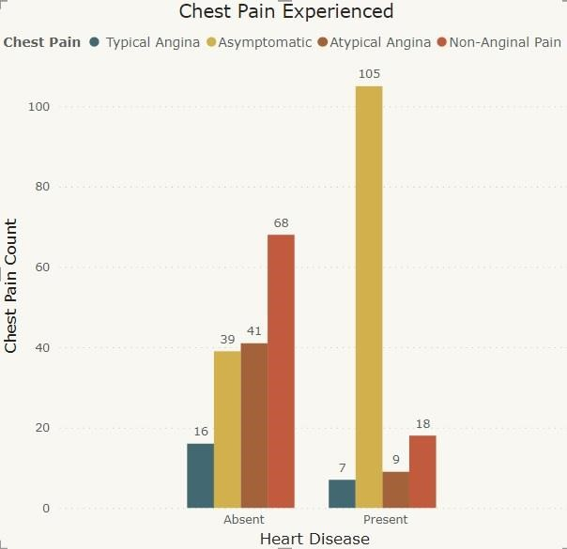

➢

It seems people having

asymptomatic chest pain have

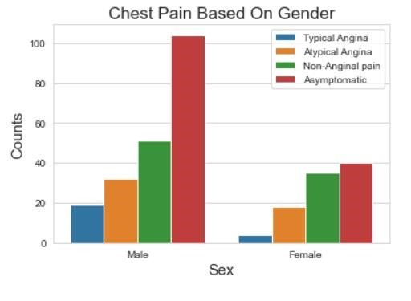

➢

We can see that a higher number of

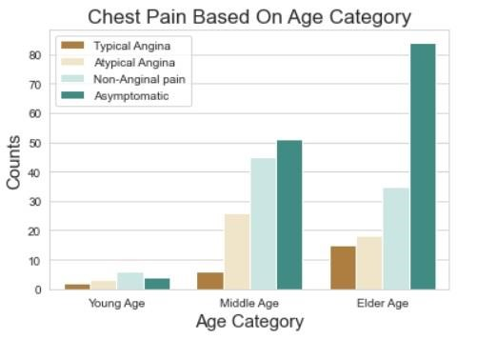

➢

There is very high number of

men are suffering from Asymptomatic Pain in Elderly

a higher chance of heart Asymptomatic type of Chest Pain age Category disease.

Asymptomatic Chest pain means neither causing nor

exhibiting symptoms of heart disease.

## Other symptoms people experience in heart disease

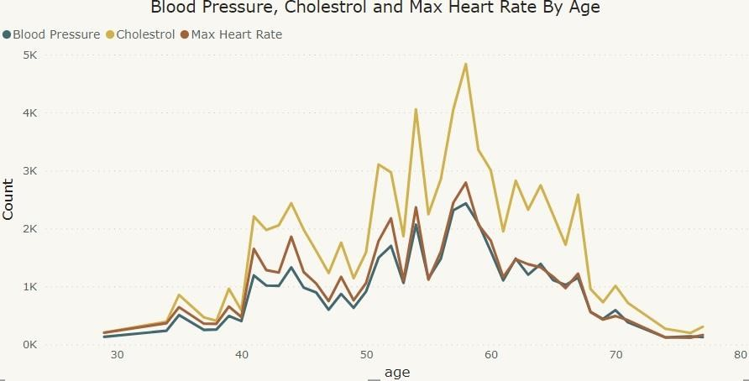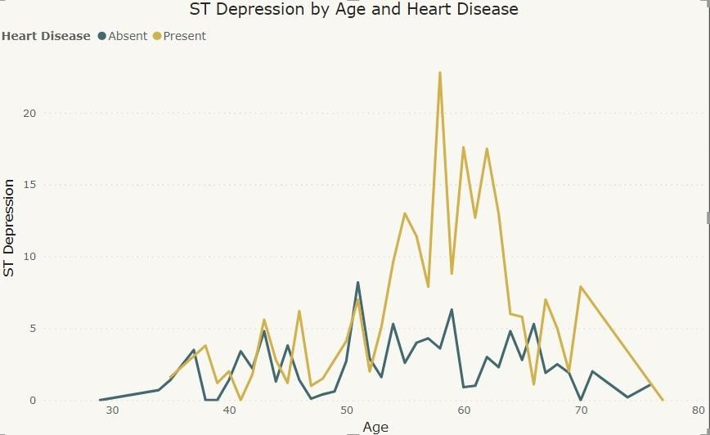

ST depression refers to a

finding on an

electrocardiogram,

wherein the trace in the ST

segment is abnormally low

below the baseline.

* Here we can observe that Blood Pressure increases between age of 50 to 60 and somehow continue the pattern till 70.
* Similarly, Cholesterol and maximum heart rate Increasing in the age group of 50-60.
* we can observe from here that ST depression mostly increases between the age group of 30-40.



KEY PERFORMANCE INDICATOR (KPI)

1.

Percentage of People Having Heart Disease

2.

Age Distribution including Gender

3.

Gender Distribution Based on Heart Disease

4.

Chest Pain Experienced by People Suffering from Heart Disease

5.

Blood Pressure, Cholesterol Level and Maximum Heart Rate of

People According to their Age and Heart Disease Patients.

6.

ST Depression Experienced by People According to their age and

heart disease.



CONCLUSION

➢

45.87

% People suffering from heart disease.

➢

Elderly Aged Men are more (50 to 60 Years) and Females are more in 55 to 65 Years Category

➢

Males are more prone to heart disease.

➢

Elderly Aged People are more prone to heart disease.

➢

P

eople having asymptomatic chest pain have a higher chance of heart disease.

➢

H

igh number of cholesterol level in people having heart disease.

➢

Blood Pressure increases between age of 50 to 60 and somehow continue till 70.

➢

Cholesterol and maximum heart rate Increasing in the age group of 50

-

60.

➢

ST depression mostly increases between the age group of 30

-

40.



Q & A

**Q1) What’s the source of data?**

Ans)

The Dataset was taken from iNeuron’s Provided Project Description Document.

[https://drive.google.com/drive/folders/165Pjmfb9W9PGy0rZjHEA22LW0Lt3](https://drive.google.com/drive/folders/165Pjmfb9W9PGy0rZjHEA22LW0Lt3Y-Q8)

[Y](https://drive.google.com/drive/folders/165Pjmfb9W9PGy0rZjHEA22LW0Lt3Y-Q8)

[-](https://drive.google.com/drive/folders/165Pjmfb9W9PGy0rZjHEA22LW0Lt3Y-Q8)

[8](https://drive.google.com/drive/folders/165Pjmfb9W9PGy0rZjHEA22LW0Lt3Y-Q8)

[Q](https://drive.google.com/drive/folders/165Pjmfb9W9PGy0rZjHEA22LW0Lt3Y-Q8)

**Q2)**

**What was the type of data?**

Ans)

The data was the combination of numerical and Categorical values.

**Q 3) What’s the complete flow you followed in this Project?**

Ans)

Refer slide 5

th

for better Understanding

**Q4)**

**What techniques were you using for data?**

Ans)

-

Removing unwanted attributes

-

Visualizing relation of independent variables with each other and output variables

-

Removing outliers

-

Cleaning data and imputing if null values are present.

-

Converting Numerical data into Categorical values.

**Q 6) What were the libraries that you**

**used in Python?**

Ans)

I used Pandas, NumPy and

Matplotlib and Seaborn libraries in

Pandas.



THANK YOU